Krishtechtrainings

<https://krishtechtrainings.com|> +918595014719

CREATING A DEPLOYMENT

**Steps for Master**

**Step 1:** Create a file, nginx.yaml and enter the following code

apiVersion: apps/v1

kind: Deployment

metadata:

name: nginx-deployment

labels:

app: nginx

spec:

replicas: 3

selector:

matchLabels:

app: nginx

template:

metadata:

labels:

app: nginx

spec:

containers:

- name: nginx

image: nginx:1.7.9

ports:

- containerPort: 80

**Step 2:** Create the deployment using the following command:

$ kubectl create –f nginx.yaml

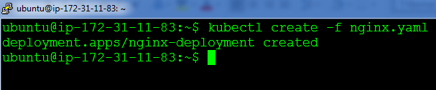

**Step 3:** Verify the procedure, by listing the pods:

$ kubectl get po

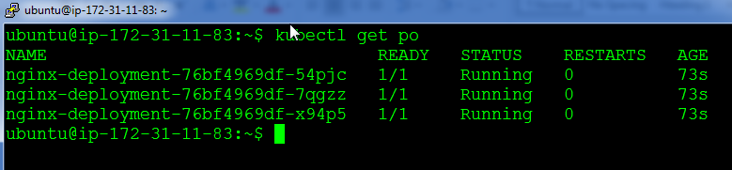

You have successfully deployed nginx on Kubernetes!!